Практическая работа 7
Тема: «Построение дерева решений»

Цель: научиться создавать и визуализировать дерево решений для анализа и принятия оптимальных управленческих решений в различных ситуациях.

Ход работы
- Дизайн
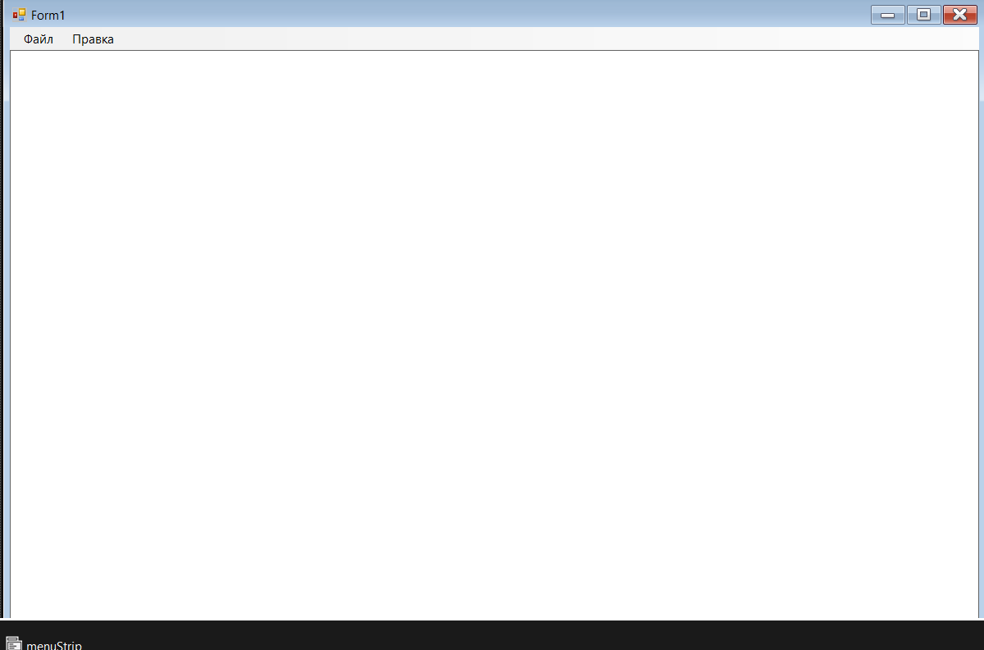
- Код
Form1
using System;
using System.Collections.Generic;
using System.Drawing;
using System.Windows.Forms;
using FamilyTreeApp.Models;
using FamilyTreeApp.Services;

namespace FamilyTreeApp
{
public partial class Form1 : Form
{
private FamilyTreeService _familyService;
private List<Person> _people;
private List<DisplayRelationship> _relationships;

private bool isAddingPerson = false;
private bool isAddingRelationship = false;
private Person selectedPersonForRelation = null;
private Person selectedPersonForDelete = null;

private Stack<Action> undoStack = new Stack<Action>();

public Form1()
{
InitializeComponent();
InitializeService();
UpdateDisplay();
UpdateMenuStates();
}

private void InitializeService()
{
_familyService = new FamilyTreeService();
_familyService.DataChanged += (s, e) =>
{
if (InvokeRequired)
Invoke(new Action(UpdateDisplay));
else
UpdateDisplay();
};
}

private void UpdateDisplay()
{
_people = _familyService.GetAllPeople();
_relationships = _familyService.GetDisplayRelationships();
drawingPanel.Invalidate();

UpdateMenuStates();
}

private void UpdateMenuStates()
{
bool hasPeople = _people != null && _people.Count > 0;

deleteSelectedToolStripMenuItem.Enabled = selectedPersonForDelete != null;

clearAllToolStripMenuItem.Enabled = hasPeople;

addRelationshipToolStripMenuItem.Enabled = hasPeople && _people.Count >= 2;
}

private void DrawingPanel_Paint(object sender, PaintEventArgs e)
{
Graphics g = e.Graphics;
g.SmoothingMode = System.Drawing.Drawing2D.SmoothingMode.AntiAlias;

DrawRelationships(g);
DrawPeople(g);
DrawModeHint(g);
DrawSelectionHint(g);
}

private void DrawRelationships(Graphics g)
{
if (_relationships == null) return;

foreach (var rel in _relationships)
{
Point from = new Point(rel.From.X, rel.From.Y);
Point to = new Point(rel.To.X, rel.To.Y);

using (Pen pen = new Pen(Color.Black, 2))
{
if (rel.RelationType == "супруг")
pen.DashStyle = System.Drawing.Drawing2D.DashStyle.Dash;

g.DrawLine(pen, from, to);
}
DrawRelationshipLabel(g, rel, from, to);
}
}

private void DrawRelationshipLabel(Graphics g, DisplayRelationship rel, Point from, Point to)
{
int midX = (from.X + to.X) / 2;
int midY = (from.Y + to.Y) / 2;

string labelText = "";
if (rel.RelationType == "родитель")
labelText = "родитель → ребенок";
else if (rel.RelationType == "ребенок")
labelText = "ребенок ← родитель";
else if (rel.RelationType == "супруг")
labelText = "супруг(а)";

SizeF textSize = g.MeasureString(labelText, SystemFonts.DefaultFont);
RectangleF textBg = new RectangleF(
midX - textSize.Width / 2 - 2,
midY - textSize.Height / 2 - 2,
textSize.Width + 4,
textSize.Height + 4
);

using (Brush bgBrush = new SolidBrush(Color.FromArgb(200, Color.White)))
{
g.FillRectangle(bgBrush, textBg);
}
using (Pen borderPen = new Pen(Color.LightGray, 1))
{
g.DrawRectangle(borderPen, textBg.X, textBg.Y, textBg.Width, textBg.Height);
}

using (Brush textBrush = new SolidBrush(Color.Black))
{
g.DrawString(labelText, SystemFonts.DefaultFont, textBrush,
midX - textSize.Width / 2, midY - textSize.Height / 2);
}
}

private void DrawPeople(Graphics g)
{
if (_people == null) return;

foreach (var person in _people)
{
SizeF textSize = g.MeasureString(person.Description, SystemFonts.DefaultFont);
int width = (int)textSize.Width + 20;
int height = (int)textSize.Height + 10;

Rectangle rect = new Rectangle(
person.X - width / 2,
person.Y - height / 2,
width,
height
);

using (Brush brush = new SolidBrush(Color.LightBlue))
{
g.FillRectangle(brush, rect);
}

using (Pen pen = new Pen(Color.Black, 1))
{
g.DrawRectangle(pen, rect);
}

if (selectedPersonForDelete != null && selectedPersonForDelete.Id == person.Id)
{
using (Pen pen = new Pen(Color.Red, 3))
{
g.DrawRectangle(pen, rect);
}

using (Brush brush = new SolidBrush(Color.Red))
{
g.DrawString("ВЫБРАНО", new Font("Arial", 8, FontStyle.Bold), brush,
rect.X, rect.Y - 15);
}
}

else if (selectedPersonForRelation != null && selectedPersonForRelation.Id == person.Id)
{
using (Pen pen = new Pen(Color.Blue, 3))
{
g.DrawRectangle(pen, rect);
}
}

// Текст
using (Brush brush = new SolidBrush(Color.Black))
{
g.DrawString(person.Description, SystemFonts.DefaultFont, brush,
rect.X + 10, rect.Y + 5);
}
}
}

private void DrawModeHint(Graphics g)
{
string hint = "";
if (isAddingPerson)
hint = "Режим: добавление человека. Щелкните по пустому месту.";
else if (isAddingRelationship)
{
if (selectedPersonForRelation == null)
hint = "Режим: добавление связи. Выберите первого человека (родителя/супруга)...";
else
hint = "Режим: добавление связи. Выберите второго человека (ребенка/супруга)...";
}

if (!string.IsNullOrEmpty(hint))
{
using (Font font = new Font("Arial", 10, FontStyle.Italic))
using (Brush brush = new SolidBrush(Color.Gray))
{
g.DrawString(hint, font, brush, 10, 50);
}
}
}

private void DrawSelectionHint(Graphics g)
{
if (selectedPersonForDelete != null)
{
string hint = "Нажмите 'Удалить выбранное' для удаления этого человека и всех его связей";
using (Font font = new Font("Arial", 9, FontStyle.Italic))
using (Brush brush = new SolidBrush(Color.Red))
{
g.DrawString(hint, font, brush, 10, 70);
}
}
}

private void DrawingPanel_MouseClick(object sender, MouseEventArgs e)
{
if (isAddingPerson)
{
AddNewPersonAtLocation(e.Location);
isAddingPerson = false;
}
else if (isAddingRelationship)
{
HandleRelationshipClick(e.Location);
}
else
{
SelectPersonForDelete(e.Location);
}

drawingPanel.Invalidate();
}

private void HandleRelationshipClick(Point location)
{
Person clickedPerson = FindPersonAtLocation(location);

if (clickedPerson != null)
{
if (selectedPersonForRelation == null)
{
selectedPersonForRelation = clickedPerson;
}
else
{
if (selectedPersonForRelation.Id == clickedPerson.Id)
{
MessageBox.Show("Нельзя создать связь с самим собой!",
"Ошибка", MessageBoxButtons.OK, MessageBoxIcon.Warning);
return;
}

if (RelationshipExists(selectedPersonForRelation.Id, clickedPerson.Id))
{
MessageBox.Show("Такая связь уже существует!",
"Ошибка", MessageBoxButtons.OK, MessageBoxIcon.Warning);

selectedPersonForRelation = null;
return;
}

AddRelationshipBetween(selectedPersonForRelation, clickedPerson);

selectedPersonForRelation = null;
}
}
}

private bool RelationshipExists(int person1Id, int person2Id)
{
foreach (var rel in _relationships)
{
if ((rel.From.Id == person1Id && rel.To.Id == person2Id) ||
(rel.From.Id == person2Id && rel.To.Id == person1Id))
{
return true;
}
}
return false;
}

private void SelectPersonForDelete(Point location)
{
Person clickedPerson = FindPersonAtLocation(location);

if (clickedPerson != null)
{
if (selectedPersonForDelete != null && selectedPersonForDelete.Id == clickedPerson.Id)
{
selectedPersonForDelete = null;
}
else
{
selectedPersonForDelete = clickedPerson;
}

UpdateMenuStates();
}
}

private Person FindPersonAtLocation(Point location)
{
foreach (var person in _people)
{
int tolerance = 30;
if (Math.Abs(person.X - location.X) < tolerance &&
Math.Abs(person.Y - location.Y) < tolerance)
{
return person;
}
}
return null;
}

private void AddNewPersonAtLocation(Point location)
{
using (var dialog = new AddPersonDialog())
{
if (dialog.ShowDialog() == DialogResult.OK)
{
if (string.IsNullOrWhiteSpace(dialog.FullName))
{
MessageBox.Show("Имя не может быть пустым!",
"Ошибка", MessageBoxButtons.OK, MessageBoxIcon.Warning);
return;
}

if (dialog.BirthDate > DateTime.Now)
{
MessageBox.Show("Дата рождения не может быть в будущем!",
"Ошибка", MessageBoxButtons.OK, MessageBoxIcon.Warning);
return;
}

var person = _familyService.AddPerson(
dialog.FullName,
dialog.BirthDate
);

person.X = location.X;
person.Y = location.Y;

SaveUndoState(() => _familyService.DeletePerson(person.Id));

_familyService.NotifyDataChanged();
}
}
}

private void AddRelationshipBetween(Person person1, Person person2)
{
using (var dialog = new AddRelationshipDialog())
{
dialog.SetPersonInfo(person1.FullName, person2.FullName);

if (dialog.ShowDialog() == DialogResult.OK)
{
string relationType = dialog.RelationType;

if (!IsValidRelationship(person1, person2, relationType))
{
return;
}

SaveUndoState(() => {
});

if (relationType == "супруг")
{
_familyService.AddRelationship(person1.Id, person2.Id, "супруг");
}
else if (relationType == "родитель-ребенок")
{
_familyService.AddRelationship(person1.Id, person2.Id, "родитель");
}
}
}
}

private bool IsValidRelationship(Person person1, Person person2, string relationType)
{
if (RelationshipExists(person1.Id, person2.Id))
{
MessageBox.Show("Такая связь уже существует!",
"Ошибка", MessageBoxButtons.OK, MessageBoxIcon.Warning);
return false;
}

if (relationType == "родитель-ребенок")
{
if (person1.BirthDate >= person2.BirthDate)
{
var result = MessageBox.Show(
"Внимание: родитель младше ребенка или они одного возраста. Это возможно только для приемных родителей. Продолжить?",
"Проверка возраста",
MessageBoxButtons.YesNo,
MessageBoxIcon.Question);

return result == DialogResult.Yes;
}
}

return true;
}

private void SaveUndoState(Action undoAction)
{
undoStack.Push(undoAction);

undoToolStripMenuItem.Enabled = true;
}

private void AddPersonMenuItem_Click(object sender, EventArgs e)
{
isAddingPerson = true;
isAddingRelationship = false;
selectedPersonForRelation = null;
selectedPersonForDelete = null;
UpdateMenuStates();
}

private void AddRelationshipMenuItem_Click(object sender, EventArgs e)
{
if (_people.Count < 2)
{
MessageBox.Show("Для создания связи нужно хотя бы 2 человека!",
"Недостаточно людей", MessageBoxButtons.OK, MessageBoxIcon.Information);
return;
}

isAddingPerson = false;
isAddingRelationship = true;
selectedPersonForRelation = null;
selectedPersonForDelete = null;
UpdateMenuStates();
}

private void DeleteSelectedMenuItem_Click(object sender, EventArgs e)
{
if (selectedPersonForDelete == null)
{
MessageBox.Show("Сначала выберите человека для удаления (кликните по нему)",
"Нет выбранного объекта", MessageBoxButtons.OK, MessageBoxIcon.Information);
return;
}

string message = $"Удалить {selectedPersonForDelete.FullName} и все связанные с ним связи?";
if (MessageBox.Show(message, "Подтверждение удаления",
MessageBoxButtons.YesNo, MessageBoxIcon.Question) == DialogResult.Yes)
{
var deletedPerson = selectedPersonForDelete;
SaveUndoState(() => {
});

_familyService.DeletePerson(selectedPersonForDelete.Id);
selectedPersonForDelete = null;
UpdateMenuStates();
}
}

private void ClearAllMenuItem_Click(object sender, EventArgs e)
{
if (MessageBox.Show("Очистить всё дерево? Это действие нельзя отменить!",
"Подтверждение", MessageBoxButtons.YesNo, MessageBoxIcon.Warning) == DialogResult.Yes)
{
SaveUndoState(() => {
});

_familyService.ClearAll();
isAddingPerson = false;
isAddingRelationship = false;
selectedPersonForRelation = null;
selectedPersonForDelete = null;
undoStack.Clear();
undoToolStripMenuItem.Enabled = false;
UpdateMenuStates();
}
}

private void UndoToolStripMenuItem_Click(object sender, EventArgs e)
{
if (undoStack.Count > 0)
{
var undoAction = undoStack.Pop();
undoAction?.Invoke();

if (undoStack.Count == 0)
undoToolStripMenuItem.Enabled = false;
}
}
}

public class AddPersonDialog : Form
{
public string FullName { get; private set; }
public DateTime BirthDate { get; private set; }

private TextBox txtName;
private DateTimePicker dtpBirth;
private Button btnOk;
private Button btnCancel;

public AddPersonDialog()
{
this.Text = "Добавить человека";
this.Size = new Size(300, 200);
this.StartPosition = FormStartPosition.CenterParent;
this.FormBorderStyle = FormBorderStyle.FixedDialog;
this.MaximizeBox = false;
this.MinimizeBox = false;

Label lblName = new Label { Text = "ФИО:", Location = new Point(10, 20), Size = new Size(80, 20) };
txtName = new TextBox { Location = new Point(100, 20), Size = new Size(150, 20) };

Label lblBirth = new Label { Text = "Дата рождения:", Location = new Point(10, 50), Size = new Size(80, 20) };
dtpBirth = new DateTimePicker
{
Location = new Point(100, 50),
Size = new Size(150, 20),
Format = DateTimePickerFormat.Short,
MaxDate = DateTime.Now,
Value = DateTime.Now.AddYears(-30)
};

btnOk = new Button { Text = "OK", Location = new Point(60, 100), Size = new Size(75, 30), DialogResult = DialogResult.OK };
btnCancel = new Button { Text = "Отмена", Location = new Point(150, 100), Size = new Size(75, 30), DialogResult = DialogResult.Cancel };

this.Controls.AddRange(new Control[] { lblName, txtName, lblBirth, dtpBirth, btnOk, btnCancel });

btnOk.Click += (s, e) =>
{
if (string.IsNullOrWhiteSpace(txtName.Text))
{
MessageBox.Show("Введите ФИО!", "Ошибка", MessageBoxButtons.OK, MessageBoxIcon.Warning);
this.DialogResult = DialogResult.None;
return;
}

FullName = txtName.Text.Trim();
BirthDate = dtpBirth.Value;
};
}
}

public class AddRelationshipDialog : Form
{
public string RelationType { get; private set; }

private ComboBox cmbType;
private Button btnOk;
private Button btnCancel;
private Label lblPersonInfo;

public AddRelationshipDialog()
{
this.Text = "Тип связи";
this.Size = new Size(350, 180);
this.StartPosition = FormStartPosition.CenterParent;
this.FormBorderStyle = FormBorderStyle.FixedDialog;
this.MaximizeBox = false;
this.MinimizeBox = false;

lblPersonInfo = new Label
{
Text = "Выберите тип связи:",
Location = new Point(10, 10),
Size = new Size(320, 20),
TextAlign = ContentAlignment.MiddleCenter
};

Label lblType = new Label { Text = "Тип связи:", Location = new Point(10, 40), Size = new Size(80, 20) };

cmbType = new ComboBox
{
Location = new Point(100, 40),
Size = new Size(200, 20),
DropDownStyle = ComboBoxStyle.DropDownList
};

cmbType.Items.AddRange(new string[] {
"родитель-ребенок",
"супруг"
});
cmbType.SelectedIndex = 0;

btnOk = new Button { Text = "OK", Location = new Point(80, 80), Size = new Size(75, 30), DialogResult = DialogResult.OK };
btnCancel = new Button { Text = "Отмена", Location = new Point(180, 80), Size = new Size(75, 30), DialogResult = DialogResult.Cancel };

this.Controls.AddRange(new Control[] { lblPersonInfo, lblType, cmbType, btnOk, btnCancel });

btnOk.Click += (s, e) =>
{
RelationType = cmbType.SelectedItem.ToString();
};
}

public void SetPersonInfo(string person1Name, string person2Name)
{
lblPersonInfo.Text = $"Связь между {person1Name} и {person2Name}";
}
}
}
Models.cs
using System;
using System.Collections.Generic;

namespace FamilyTreeApp.Models
{
public class Person
{
public int Id { get; set; }
public string FullName { get; set; }
public DateTime BirthDate { get; set; }
public string Description
{
get
{
return $"{FullName}\n{BirthDate:dd.MM.yyyy}";
}
}

public int X { get; set; }
public int Y { get; set; }

public Person(int id, string fullName, DateTime birthDate)
{
Id = id;
FullName = fullName;
BirthDate = birthDate;
}
}

public class Relationship
{
public int Id { get; set; }
public int FromPersonId { get; set; }
public int ToPersonId { get; set; }
public string RelationType { get; set; }

public Relationship(int id, int fromId, int toId, string type)
{
Id = id;
FromPersonId = fromId;
ToPersonId = toId;
RelationType = type;
}
}

public class DisplayRelationship
{
public Person From { get; set; }
public Person To { get; set; }
public string RelationType { get; set; }
}
}
Services.cs
using System;
using System.Collections.Generic;
using System.Linq;
using FamilyTreeApp.Models;

namespace FamilyTreeApp.Services
{
public class FamilyTreeService
{
private List<Person> _people;
private List<Relationship> _relationships;
private int _nextPersonId;
private int _nextRelationshipId;

public event EventHandler DataChanged;

public FamilyTreeService()
{
_people = new List<Person>();
_relationships = new List<Relationship>();
_nextPersonId = 1;
_nextRelationshipId = 1;
}

public List<Person> GetAllPeople() => _people;
public List<Relationship> GetAllRelationships() => _relationships;

public List<DisplayRelationship> GetDisplayRelationships()
{
var result = new List<DisplayRelationship>();

foreach (var rel in _relationships)
{
var from = _people.FirstOrDefault(p => p.Id == rel.FromPersonId);
var to = _people.FirstOrDefault(p => p.Id == rel.ToPersonId);

if (from != null && to != null)
{
result.Add(new DisplayRelationship
{
From = from,
To = to,
RelationType = rel.RelationType
});
}
}

return result;
}

public Person AddPerson(string fullName, DateTime birthDate)
{
var person = new Person(_nextPersonId++, fullName, birthDate);

person.X = 400;
person.Y = 200 + (_people.Count * 60);

_people.Add(person);

OnDataChanged();
return person;
}

public void AddRelationship(int fromId, int toId, string type)
{
var from = _people.FirstOrDefault(p => p.Id == fromId);
var to = _people.FirstOrDefault(p => p.Id == toId);

if (from != null && to != null)
{
if (RelationshipExists(fromId, toId, type))
{
return;
}

if (type == "супруг")
{
_relationships.Add(new Relationship(_nextRelationshipId++, fromId, toId, "супруг"));
_relationships.Add(new Relationship(_nextRelationshipId++, toId, fromId, "супруг"));
}
else
{
_relationships.Add(new Relationship(_nextRelationshipId++, fromId, toId, type));
}

OnDataChanged();
}
}

private bool RelationshipExists(int fromId, int toId, string type)
{
if (type == "супруг")
{
return _relationships.Any(r =>
(r.FromPersonId == fromId && r.ToPersonId == toId && r.RelationType == "супруг") ||
(r.FromPersonId == toId && r.ToPersonId == fromId && r.RelationType == "супруг"));
}
else
{
return _relationships.Any(r =>
r.FromPersonId == fromId && r.ToPersonId == toId && r.RelationType == type);
}
}

public void DeletePerson(int personId)
{
var person = _people.FirstOrDefault(p => p.Id == personId);
if (person != null)
{
_relationships.RemoveAll(r => r.FromPersonId == personId || r.ToPersonId == personId);

_people.Remove(person);

OnDataChanged();
}
}

public void ClearAll()
{
_people.Clear();
_relationships.Clear();
_nextPersonId = 1;
_nextRelationshipId = 1;
OnDataChanged();
}

public void NotifyDataChanged()
{
OnDataChanged();
}

protected virtual void OnDataChanged()
{
DataChanged?.Invoke(this, EventArgs.Empty);
}
}
}

- Тестирование
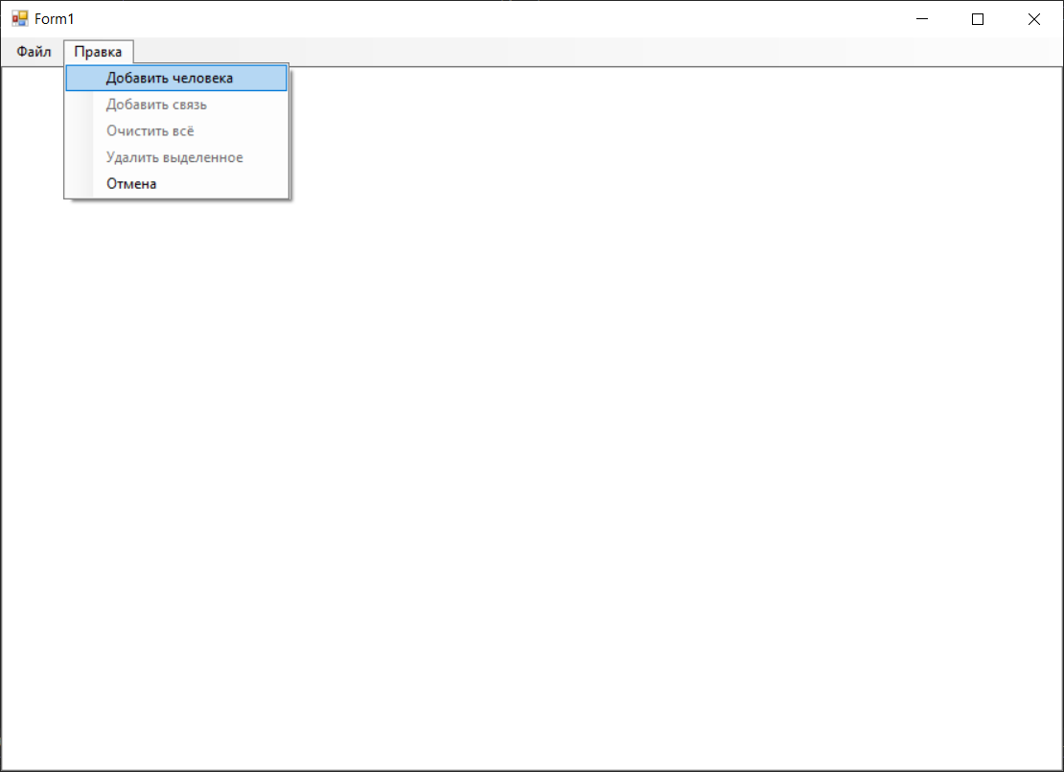
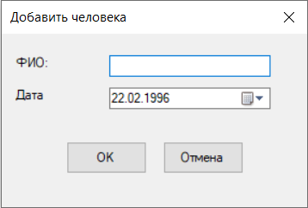
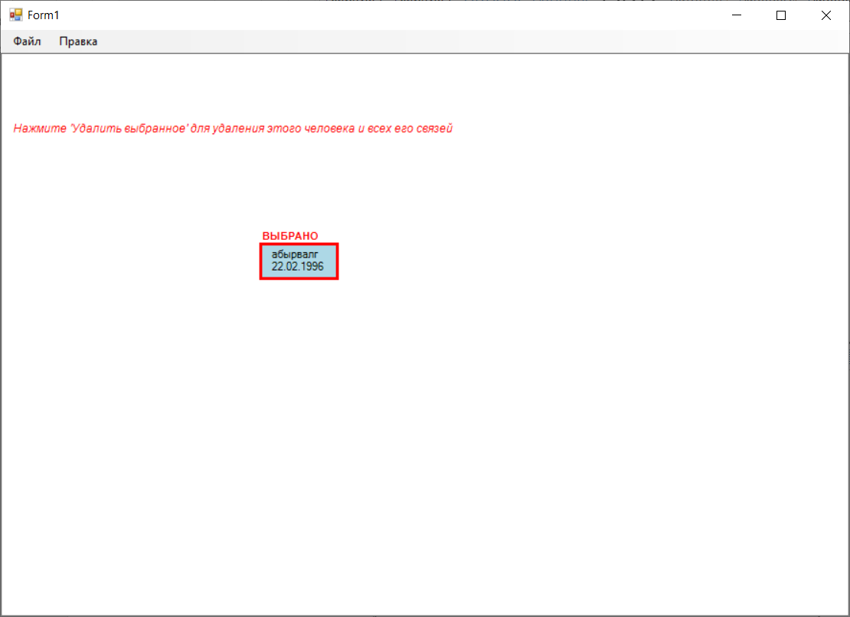
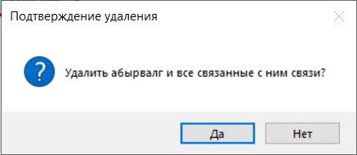
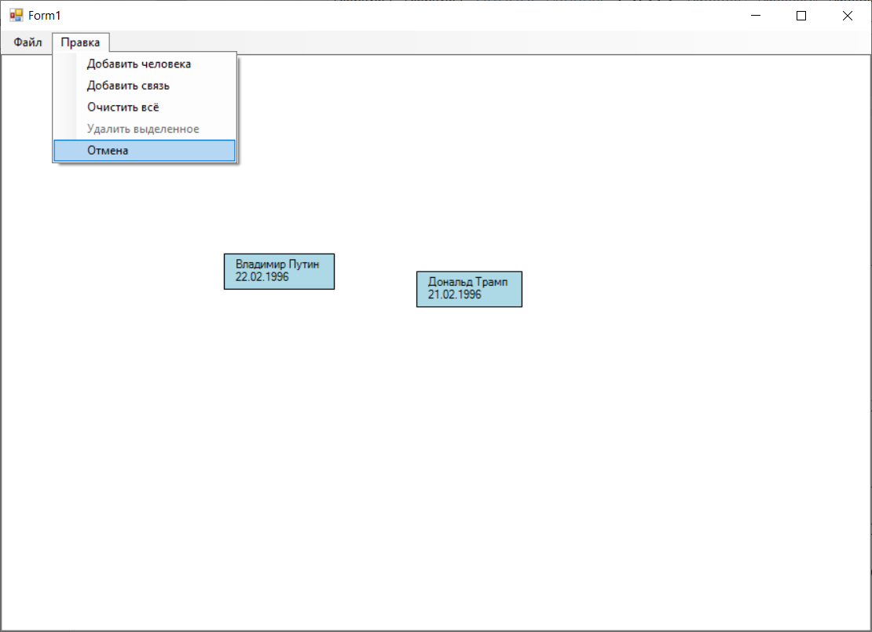
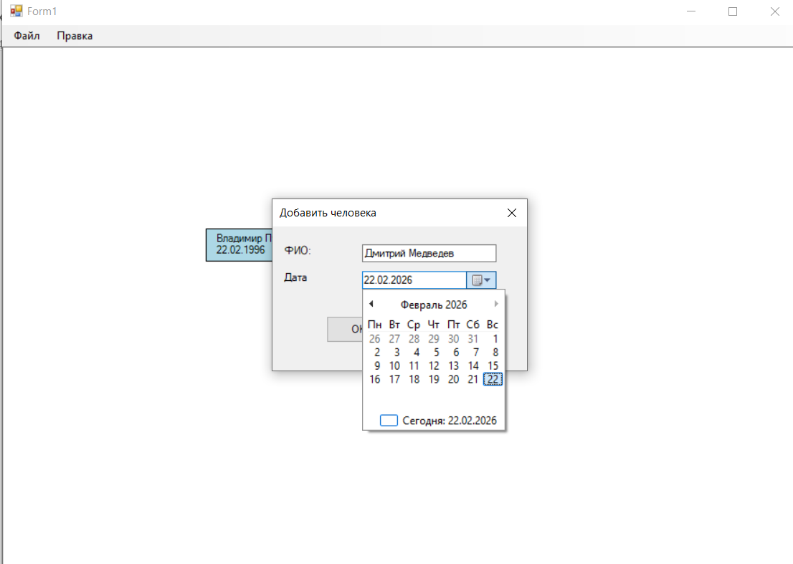
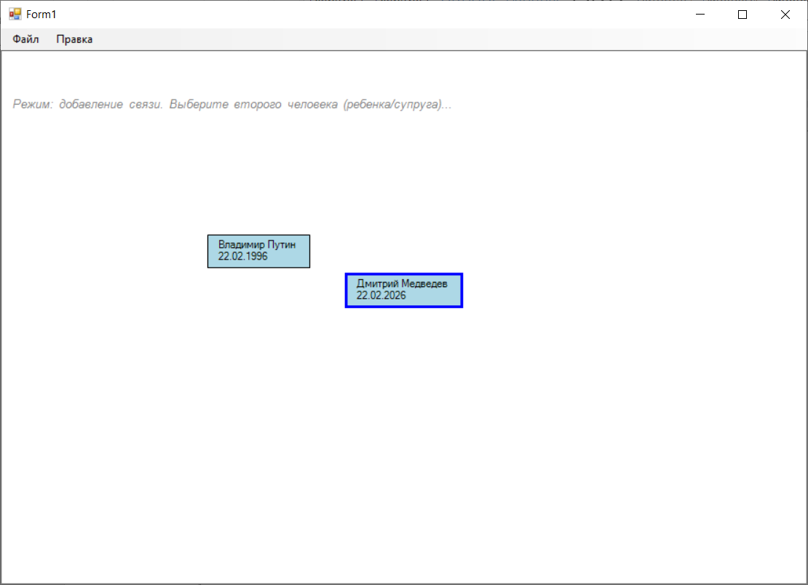
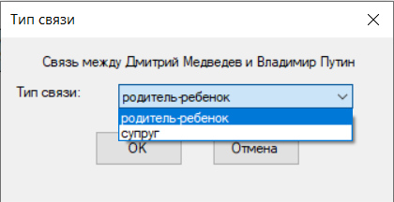
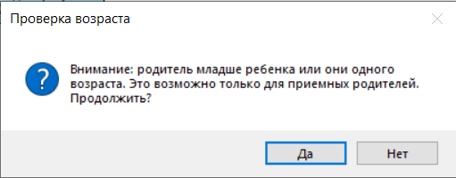
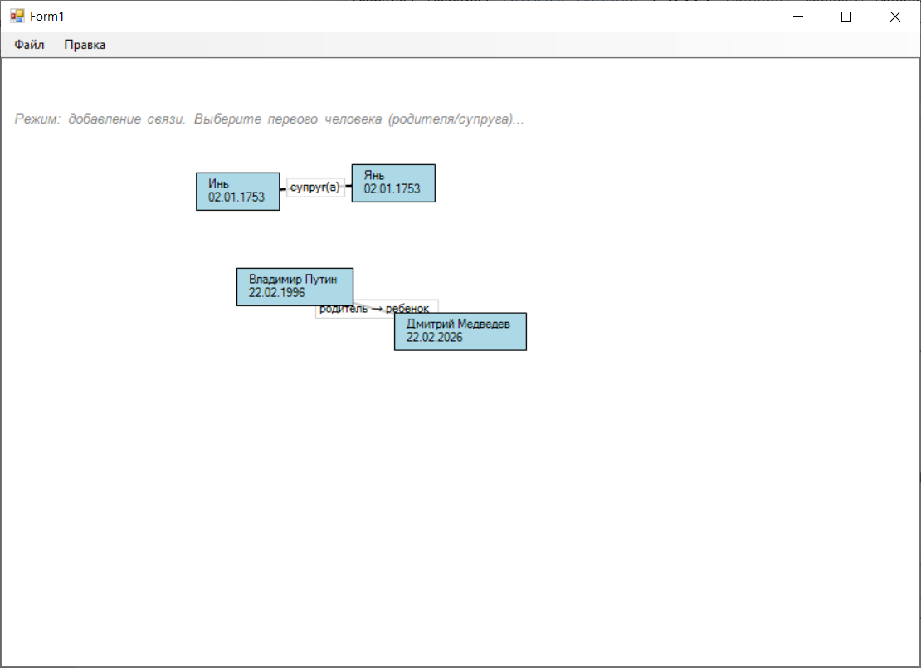
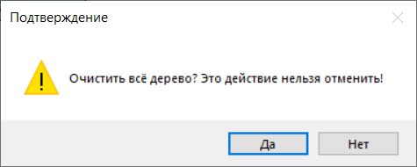
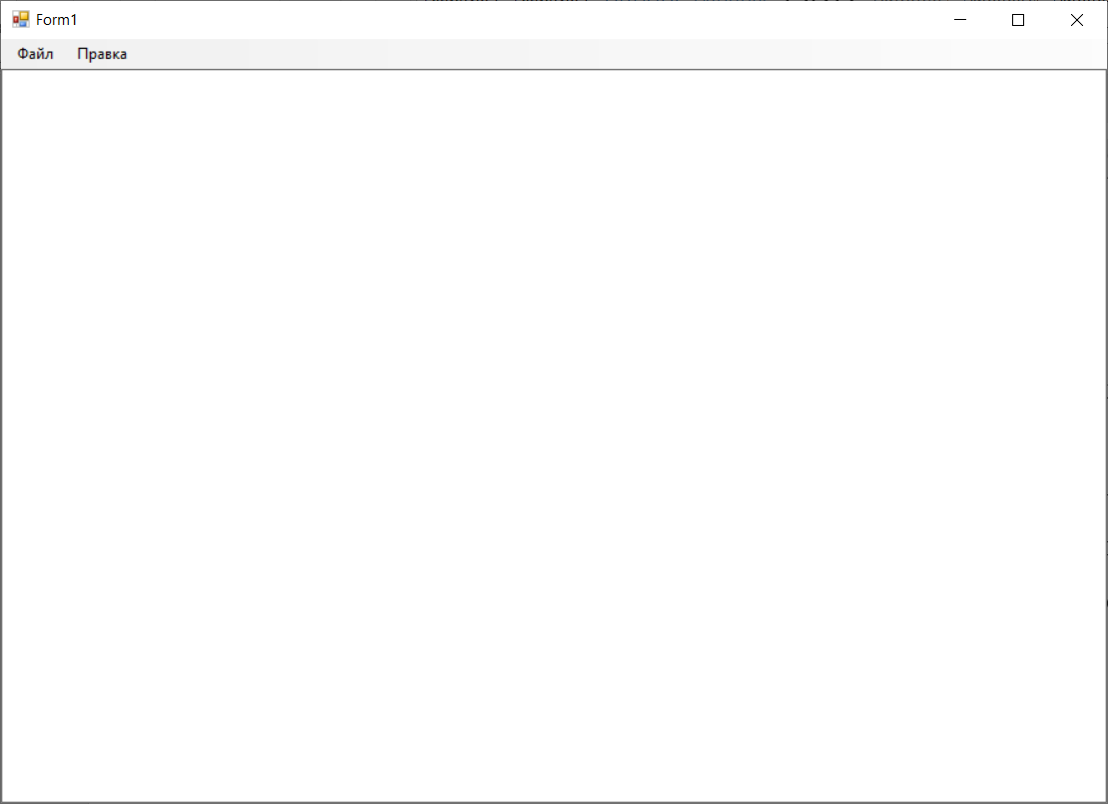
Контрольные вопросы
- Граф — это математическая структура, состоящая из множества вершин (узлов) и множества рёбер (связей между вершинами). Состоит из вершины (допустим город), рёбер (допустим дороги), веса (допустим расстояние) и направления (не всегда).
- Неориентированный (ребра не имеют направлений), ориентированный(имеют), с петлями (ребро совершает круг и возвращается в вершину), мультиграф (у вершины могут быть 2 параллельных ребра)
- В первую очередь при построении транспортной сети и городского планирования. Бизнес и научные схемы также активно используют модели графов при огромном количестве выбора.
- Граф намного свободнее дерево решений, ибо последнее движется сверху вниз, принимая движения да или нет. У графов путь нелинейный, возможны циклы, направление любое.
- Алгоритм Дейкстра- поиск кратчайшего пути от вершины графа до любой другой и алгоритм Беллмана-Форда, если граф содержит ребра с отрицательным весом.

